Online Temperature Prediction in Aluminium Electrolysis Cells Using KSI Reasoning and a Dynamic Takagi Sugeno Model

Abstract
We study a compact soft sensor for bath-temperature prediction in aluminium electrolysis cells. The model combines moving-distance reasoning associated with the KSI principle, affine Takagi–Sugeno consequents, and recursive least-squares updates when thermocouple measurements become available. Continuously measured voltage and current provide the main input channels, while sparse temperature observations supervise adaptation. The formulation defines antecedent distances, distinguishes alternative rule-effect operators, and makes the dimensions and timing of the recursive update explicit. Pseudocode covers membership-distance evaluation, rule normalization, prediction, delayed-label handling, baseline modeling, and cell-wise validation. For the reported cell No. 2 comparison, the five-rule model has a mean error of 0.315 °C versus 2.289 °C for a 25-rule ANFIS baseline, an 86.24% reduction in the reported error measure. In the three-cell field table, mean deviation decreases from 2.80 to 1.57 °C for cell No. 15 but increases from 2.40 to 2.94 °C and from 2.60 to 6.05 °C for cells Nos. 48 and 89. Reported accuracy indices improve in all three cells, but their mathematical definition is unavailable. The figures make this discrepancy visible and separate empirical aggregates from analytic complexity illustrations. The evidence supports further evaluation of a small, interpretable online predictor, while standardized metrics, timestamped data, the exact activation operator, and common-data baseline experiments remain necessary for a general performance claim.
Keywords: aluminium electrolysis; bath temperature; soft sensor; KSI principle; Takagi–Sugeno model; recursive least squares; delayed labels

1 Introduction
Bath temperature reflects the thermal state of an aluminium reduction cell and is closely connected to its energy balance, ledge behavior, bath chemistry, and operating efficiency. In this paper, “cell” means one Hall–Héroult electrolytic pot, not a battery. The pot contains a cryolitic molten electrolyte and molten aluminium, with carbon anodes above and a cathode lining below. High current drives the electrochemical reaction and contributes to heat generation. A temperature soft sensor estimates the bath condition from other measurements when continuous direct measurement is difficult.
The practical problem combines continuous electrical observations with sparse temperature supervision. The recorded application describes thermocouple measurements approximately every three hours and more frequent voltage/current acquisition. Those intervals are plant-specific observations, not universal specifications. A predictor must state whether it estimates the current unmeasured temperature, forecasts temperature at a future time, or reconstructs temperature retrospectively after measurements arrive. These tasks have different information sets and should not share an unqualified “real-time accuracy” claim.
Data-driven soft sensing is an established approach in process engineering [1]. In aluminium electrolysis, a recent bibliometric study describes the broad development of modeling and intelligent process analysis [2]. The important design question here is narrower: can a low-input, small-rule model adapt online using sparse labels while maintaining a transparent relationship between measurements, rule activations, and predicted temperature?

1.1 Recent aluminium process research through 2026
Lin and colleagues’ 2025 bath-temperature study compares five machine-learning models on production data from a 500-kA cell and reports the best performance for LightGBM [3]. It uses production features beyond voltage and current and reports an average predicted–measured difference of 1.6 °C. That result establishes a relevant data-rich comparator, but its error value is not directly interchangeable with an error measured on a different cell, time interval, or feature set.
In 2026, Chen and colleagues combine MHD-CFD data with machine-learning surrogates for side-ledge morphology and temperature fields [4]. Novozhilov and colleagues develop coupled electro-thermal field modeling using finite differences [5]. These studies concern spatially resolved thermal behavior, whereas the present soft sensor predicts a scalar bath-temperature quantity. They indicate complementary modeling choices: a detailed field model provides physical spatial structure, while a compact online estimator targets frequent updates with limited process inputs.
Related 2025 work on liquidus-temperature prediction evaluates machine-learning models for cryolitic bath composition [6]. Liquidus temperature is not the same target as actual bath temperature; their difference is the superheat. A 2025 CNN–LSTM conference contribution addresses temperature-field prediction [7]. These distinctions matter when describing novelty and comparing errors. A model for a composition-dependent phase boundary or a spatial field should not be ranked against a scalar soft sensor merely because all outputs are expressed in degrees Celsius.

1.2 Fuzzy inference and KSI reasoning
Fuzzy sets and linguistic modeling provide interpretable nonlinear representations [8, 9]. A Takagi–Sugeno system blends affine local models using input-dependent rule effects [10, 11]. Rule learning from examples and evolving T–S identification show that model structure and online adaptation have substantial prior foundations [12, 13]. Consequently, this study’s contribution should be located in the chosen moving-distance activation and its application under sparse temperature labels, rather than in claiming that recursive or interpretable T–S estimation is itself new.
The compensating and distance-based reasoning studies associated with the KSI principle supply the antecedent-displacement perspective [14, 15, 16]. The 2025 interval-modeling extension and the 2026 LCM-based modus ponens/tollens study develop this reasoning line further [17, 18]. Their reductive properties concern specified fuzzy inference constructions. They do not by themselves prove that a particular multi-input product/complement activation in an industrial predictor has the same property, or that it is more accurate than standard membership-based inference.

1.3 Research gap and contributions
The operational gap is the interaction of a compact rule base, sparse and potentially delayed labels, model drift, and reproducible evaluation. A model that predicts every electrical sample but receives only occasional temperature measurements must handle label age and timing explicitly. An online update that uses a temperature measured at one instant with the current regressor from another instant can introduce a systematic identification error.
This paper develops the dynamic T–S predictor with explicitly dimensioned RLS, describes the moving-distance branches for three antecedent shapes, and distinguishes complement-of-product reasoning from superficially similar but different operators. It adds timestamp-aware pseudocode, a complexity analysis, and visual reanalysis of the reported cell results. It also defines the conditions needed for fair ANFIS and modern data-driven comparisons. The field evidence is retained with its original metric labels; unreported datasets, confidence intervals, and continuous temperature trajectories are not reconstructed.
Table 1. Recent temperature and process-modeling literature. Target and feature differences prevent direct ranking of errors across these studies.
Study | Target / model | Comparison boundary
Lin et al. (2025) [3] | Scalar bath temperature / machine learning | Production feature set and 500-kA cell differ; published error is contextual evidence.
Chen et al. (2026) [4] | Ledge morphology and thermal fields / CFD–ML | Spatial field surrogate rather than the same scalar sparse-label target.
Novozhilov et al. (2026) [5] | Electro-thermal temperature field / finite differences | Physical field model can inform features or constraints; not a same-data predictor baseline.
Betsis et al. (2025) [6] | Liquidus temperature / machine learning | Composition-dependent liquidus and measured bath temperature are distinct quantities.
Feced-Mas et al.; Donkor et al. (2026) [19, 20] | Thermal control / ANFIS-related frameworks | Control-task evidence; compare adaptation, rule design, and computational workload explicitly.

2 Related models and design choices

2.1 Process information and physical interpretation
Voltage and current are informative but incomplete proxies for thermal behavior. Their product is electrical power input, yet temperature also depends on electrochemical energy consumption, heat losses, feed and tapping events, bath mass and composition, ledge changes, and stored thermal energy. An illustrative energy balance is
$C_{eff}\frac{dT}{dt}=UI−Q_{reaction}−Q_{loss}−Q_{feed}−Q_{other} \left(1\right)$
Equation (1) explains why a single instantaneous voltage/current pair need not identify temperature uniquely. Its quantities are not fitted parameters or newly measured results in this study. Dynamic lags and occasional measured temperature can help the model represent thermal memory, but cannot guarantee identifiability when important operating variables are unobserved.
Other aluminium applications predict anode effects, liquidus temperature, molten-metal height, or metal composition using data-driven methods [21, 22, 23, 24]. These studies support the feasibility of modeling process relationships while also emphasizing target specificity. Their reported accuracies should not be used as bath-temperature baselines unless the target, units, horizon, and sample population are aligned.

2.2 Sequential and ensemble predictors
The self-supervised deep LSTM study of Lei and colleagues addresses industrial temperature prediction [25]. Zhu and colleagues combine dual-attention LSTM modeling of nonstationary subsequences with ARMA modeling of stationary subsequences [26]. Lundby and colleagues investigate sparse skip-connected neural models for aluminium-cell identification, including long-horizon prediction behavior [27]. These models are relevant because temporal dependence and sparse measurements are central to the application. They should not be dismissed categorically as incapable of online adaptation or useful interpretation.
Random forests, gradient boosting, LightGBM, and XGBoost offer additional nonlinear baselines [28, 29, 30, 31]. Their inference cost can be modest for small trees, while training and update policies vary. SHAP provides one way to explain predictions after fitting [32]. A fuzzy rule path is more directly inspectable in some settings, but a short rule base is not automatically an accurate causal explanation of a physical process. Rule semantics, stability of activations, and agreement with process knowledge must still be examined.

2.3 ANFIS and recent thermal applications
ANFIS combines a Sugeno-type inference structure with adaptive learning of antecedent and consequent parameters [33]. Hybrid learning commonly alternates least-squares consequent estimation and gradient-based antecedent adaptation. The network description does not prohibit recursive updates; a fair comparison should state the actual training and adaptation strategy used for each model.
Recent thermal work includes a 2026 knowledge-driven ANFIS control framework and a 2026 hybrid Mamdani–ANFIS industrial heating-furnace controller [19, 20]. These are control tasks, rather than a direct replication of the present sparse-label aluminium-cell soft sensor. Robust hybrid ANFIS learning also addresses the effect of noise and outliers on premise and consequent estimation [34]. The relevant lesson is that the loss function, data conditioning, and rule construction should be compared explicitly, rather than assuming that all ANFIS implementations require the same training cost.
The current model fixes the antecedent geometry for a given deployment interval and updates its consequents when valid temperature labels arrive. This can simplify the update path and preserve a stable rule interpretation. The trade-off is reduced structural flexibility when a cell moves into an operating regime that the original partition does not cover. A method for detecting such a change is therefore part of deployment, not merely a future embellishment.

2.4 Drift and validation
Plant drift can arise from changes in lining, ledge, bath chemistry, instrumentation, or operating practice. General concept-drift research distinguishes changes in input distributions from changes in the predictive relationship [35]. A forgetting factor can help a linear estimator track some changes, but it cannot create a missing input variable or repair a poorly chosen rule partition. Online adaptation and periodic structure review serve different purposes.
Forecast evaluation research warns against using future observations during preprocessing, tuning, or target construction [36, 37]. This is especially important with sparse temperatures: linear interpolation between two measurements uses the later measurement and is not available online between them. A retrospectively interpolated target can be useful for visualization only if clearly identified, but cannot serve as independently measured high-frequency ground truth.

3 Dynamic T–S model with moving-distance reasoning

3.1 Information available at prediction time
At time t_{k}, form a regressor z_{k} from available voltage/current samples, selected lags, and any previous temperature information allowed by the deployment protocol. Include the age of the last thermocouple reading when that reading is used. If previous predicted temperature is substituted for an unobserved lag, this creates a recursive model and must be reproduced during evaluation. Using true future temperature lags in the test set would measure an easier task.
Table 2. Dimensions and timing variables for the online identification procedure.
Symbol | Dimension | Definition
z_k | d × 1 | Available electrical and lagged state regressors
R | Scalar | Rule count; reported value is 5
d_rj, β_r, w_r | Scalars | Antecedent distance, rule effect, normalized weight
φ_k, θ_k | pθ × 1 | Regressor and parameter vector; pθ = R(d + 1)
P_k | pθ × pθ | RLS inverse-information matrix
λ | Scalar in (0, 1] | Forgetting factor; λ = 1 gives no forgetting
t_m, t_a | Timestamps | Measurement time and later arrival time of a label

Training-scaled electrical inputs can improve numerical conditioning. The scaling parameters are fitted on the development period and frozen during a fixed-model evaluation. Online rescaling would require a corresponding transformation of θ and the covariance representation; silently changing input scales while retaining the same coefficients changes the predictor. Separate cell models should preserve their cell identifier, configuration version, and timestamp convention.

3.2 Antecedent moving distances
Let d_{rj}(z_{j}) be the normalized distance of input j from the matching region of rule r. For the stated s-type antecedent with a < c, d is one below a, declines linearly between a and c, and is zero at and above c. For the z-type antecedent it is zero at and below a, increases linearly to one at c, and remains one above c. Compact expressions are
$d_{s}\left(x\right)=clip​\left[\frac{c−x}{c−a},0,1\right], d_{z}\left(x\right)=clip​\left[\frac{x−a}{c−a},0,1\right] \left(2\right)$
For a trapezoidal matching region with a < b < c < d, the distance is zero on the plateau [b,c], one outside [a,d], and varies linearly on the shoulders:
$d_{trap}\left(x\right)=max​\left\{clip​\left[\frac{b−x}{b−a},0,1\right],clip​\left[\frac{x−c}{d−c},0,1\right]\right\} \left(3\right)$
The distances are mismatch quantities: zero denotes strongest local agreement. They are not themselves membership grades that should become larger with a stronger match. Validating this orientation at a plateau center and outside the support is an elementary but important implementation check. The strict breakpoint order prevents zero denominators; shoulder boundaries should have one consistent convention at equality.
Algorithm 1 Evaluate a moving distance
INPUT scalar x; antecedent type; ordered breakpoints
OUTPUT distance d in [0,1], where zero denotes a match
01 Validate finite input and strictly positive shoulder widths.
02 IF type is s: d ← clip((c − x)/(c − a), 0, 1).
03 ELSE IF type is z: d ← clip((x − a)/(c − a), 0, 1).
04 ELSE IF type is trapezoid:
05 left_distance ← clip((b − x)/(b − a), 0, 1)
06 right_distance ← clip((x − c)/(d_breakpoint − c), 0, 1)
07 d ← max(left_distance, right_distance)
08 ELSE reject the unsupported antecedent definition.
09 RETURN d.

3.3 Rule effects and an essential operator distinction
The product interpretation of the original complement expression gives
βr=1−j=1ddrj, wr=βrs​βs 4
This is a complement-of-product operator. It is different from a conventional conjunction of matching grades, β_{r} = Π_{j}(1−d_{rj}), and from a product of mismatch distances, β_{r} = Π_{j} d_{rj}. The latter activates a rule most strongly when all inputs mismatch. The three formulas cannot be used interchangeably under the name “product reasoning.”
Equation (4) has an OR-like feature under the product interpretation: if one distance is zero, β_{r} is one regardless of other distances. For d_{r1} = 0 and d_{r2} = 1, complement-of-product gives one, while product-of-matches gives zero. If the original wedge symbol is intended as minimum rather than product, it defines yet another operator. The implementation associated with the historical results must identify the actual operator used. This paper spells out the product interpretation and treats operator verification as a condition for reproducing those results.
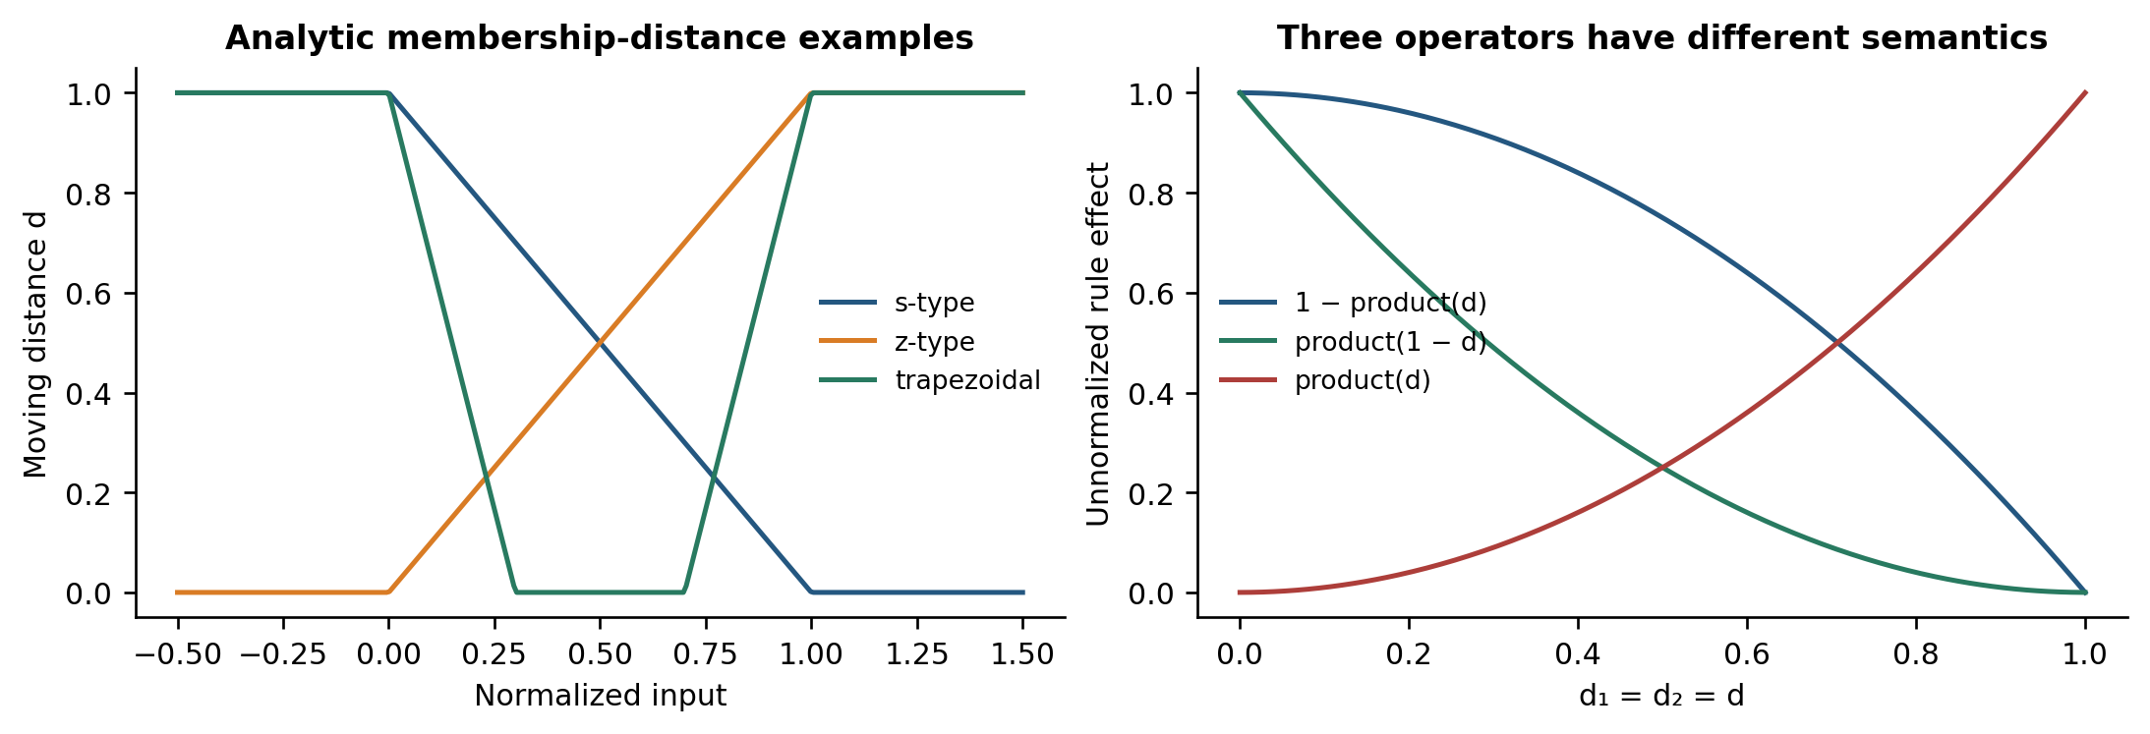
Figure 1. Analytic illustrations of moving distances and competing rule-effect operators. The right panel uses d_1 = d_2 = d to reveal their different activation directions. These curves are mathematical examples, not fitted cell data.
Algorithm 2 Compute normalized rule effects
INPUT regressor z; R rules; verified aggregation operator
OUTPUT weights w and coverage diagnostics
01 FOR each rule r:
02 FOR each antecedent j: d[r,j] ← Algorithm 1(z[j], rule[r,j]).
03 β[r] ← 1 − product_j d[r,j] for Eq. (4).
04 Use a different operator only as an explicitly named variant.
05 total ← sum_r β[r]
06 IF total > 0: w ← β / total.
07 ELSE invoke the declared no-coverage fallback and flag the sample.
08 Verify w ≥ 0 and sum(w) = 1 within numerical tolerance.
09 RETURN w, distances, raw effects, and fallback status.

For many rules, Eq. (4) can activate several rules strongly at once. This can reduce localization and alter identifiability of their consequents. The empirical comparison should therefore include product-of-matches with the same five-rule geometry. If 1−d equals a conventional piecewise-linear membership grade, product-of-matches is algebraically ordinary product inference; its novelty cannot be established by renaming membership complement as a distance.

3.4 Consequents and vector construction
For a first-order affine consequent f_{r}(z_{k}) = a_{r0} + a_{r}ᵀz_{k}, the output and design vector are
Tk=r​wrfrzk=φkTθ, pθ=Rd+1 5
$φ_{k}={\left[w_{1},w_{1}z_{k}^{T},…,w_{R},w_{R}z_{k}^{T}\right]}^{T} \left(6\right)$
Stacking the coefficients in the same order gives a p_{θ} × 1 parameter vector θ. A training design matrix has one row φ_{k}ᵀ per labeled observation. The model is nonlinear in z through its rule weights but linear in θ for a fixed antecedent definition. This is why least squares and RLS are appropriate conditional estimators [38, 39].
An autoregressive consequent can include temperature lags and delayed voltage/current terms. The same design-vector construction applies after these terms are collected in z_{k}. The regressor dimension should count all lags, not only the two physical sensor channels. A five-rule model with many lags can still contain many coefficients, so rule count alone is an incomplete measure of model capacity.

3.5 Recursive identification
With forgetting factor λ and inverse-information matrix P_{k−1}, use the standard dimensionally consistent update
$e_{k}=T_{k}−φ_{k}^{T}θ_{k−1}, K_{k}=\frac{P_{k−1}φ_{k}}{λ+φ_{k}^{T}P_{k−1}φ_{k}} \left(7\right)$
$θ_{k}=θ_{k−1}+K_{k}e_{k}, P_{k}=\frac{P_{k−1}−K_{k}φ_{k}^{T}P_{k−1}}{λ} \left(8\right)$
Both θ and K are column vectors; K e is therefore a valid parameter increment. The covariance-like matrix P has dimension p_{θ} × p_{θ}. A row/column inconsistency in a reproduced formula is a notation or implementation error, not evidence that conventional T–S modeling or the established RLS method is invalid. RLS with fixed weights is not a new estimator introduced by the KSI activation.
Initialize P₀ positive definite and document θ₀. A large diagonal P₀ expresses a weak parameter prior, but can create a large initial gain. Square-root RLS or QR methods can improve numerical conditioning. If λ < 1, repeated updates without adequate excitation can inflate uncertainty in poorly observed directions [39]. Voltage and current may be strongly correlated, so conditioning, effective rank, and parameter magnitude should be monitored.
Algorithm 3 One labeled RLS update
INPUT stored column regressor φ; measured T; θ; inverse information P; λ
OUTPUT updated θ and P; residual before the update
01 Check dimensions: φ, θ are p_θ×1; P is p_θ×p_θ.
02 Require P positive definite and 0 < λ ≤ 1.
03 residual ← T − transpose(φ)*θ
04 denominator ← λ + transpose(φ)*P*φ
05 gain ← P*φ / denominator
06 θ_new ← θ + gain*residual
07 P_new ← (P − gain*transpose(φ)*P) / λ
08 Symmetrize P_new and check conditioning.
09 RETURN θ_new, P_new, residual, and numerical diagnostics.

3.6 Output bounds and recursive stability
With nonnegative normalized weights, the instantaneous prediction lies between the smallest and largest local consequent outputs. This is a convex-combination property for the current regressor, not an unconditional temperature bound. Large coefficients or out-of-range regressors can still produce implausible values. Clipping the displayed temperature may hide this problem and changes the prediction being scored; raw and clipped outputs must be retained separately if clipping is used.
When predictions enter future temperature lags, the system becomes recursive. Stable individual local recursions do not by themselves ensure stability under changing weights [40, 41]. A common Lyapunov condition or a suitable contraction bound is needed. In the absence of such a certificate, long open-loop rollouts and out-of-range tests provide empirical diagnostics but should not be called a proof.

4 Data preparation and online deployment

4.1 Cell identity and synchronization
Each training record should contain cell identifier, measurement timestamp, ingestion timestamp, source channel, value, engineering units, and quality flags. Thermocouple time should refer to the physical measurement, not only the time at which the reading was entered into a database. Voltage/current aggregates must end at or before the prediction timestamp. Centred smoothing or interpolation across a future measurement introduces unavailable information.
Missing electrical inputs, sensor dropouts, and invalid temperature readings require an explicit policy. Holding the last electrical value can be acceptable over a short validated gap, but its age should be logged. An unmeasured temperature is not a zero-temperature observation. Outlier rejection should use engineering validity rules or thresholds fitted on the training period; deleting large test errors because they appear inconvenient biases the evaluation.
The recorded study states that models were developed for 60 cells, but the available numeric tables report only selected cell results. A complete study should provide a manifest for all cells with their development and evaluation intervals. Cell identifiers such as 89 need not represent the number of cells; identities and sample counts must be stated separately.

4.2 Delayed labels and parameter-update order
At prediction time, store the exact regressor and model version used to generate T̂. When a thermocouple label arrives, associate it with that measurement-time regressor. Updating current coefficients using the stored φ is different from recomputing φ from current electrical observations. If labels arrive out of order, a bounded-lateness buffer can process them in measurement-time order; alternatives such as replay or rejecting excessively stale labels need to be declared.
Forgetting can be indexed by labeled updates or by elapsed physical time. With irregular labels, a fixed λ per update weights equally spaced updates rather than equal time intervals. A time-aware form λ(Δt) can represent a chosen physical forgetting horizon, but it is a separate configured model choice. No forgetting or information inflation should be applied silently on unlabeled ticks.
Algorithm 4 Predict continuously and assimilate delayed measurements
INPUT cell model; timestamped electrical stream; thermocouple stream
lag buffer; pending-regressor store; label-ordering policy
OUTPUT temperature estimates and versioned adaptation record
01 FOR each electrical sampling instant t:
02 Validate signals and form z_t using information available at t.
03 Compute weights by Algorithm 2; construct φ_t by Eq. (6).
04 prediction_t ← transpose(φ_t)*θ_current
05 Store t, φ_t, prediction_t, model version, and input ages.
06 Publish prediction_t with its validity and coverage status.
07 FOR each accepted label with measurement timestamp t_m:
08 Retrieve the stored regressor for t_m, not the current one.
09 Score the stored pre-update prediction against the label.
10 Process labels in the declared chronological order.
11 Apply Algorithm 3 and increment the model version.
12 If labels are missing, retain θ and apply the declared P policy.
13 Log stale-label, missing-regressor, and out-of-range events.

The prediction used for evaluation in line 9 must be the estimate issued before the label arrived. Recomputing a fitted value after parameter correction produces an assimilation error, not an operational prediction error. Both can be useful diagnostics, but they answer different questions.

4.3 Training and acceptance
A development period identifies scaling, lags, antecedent breakpoints, rule count, regularization, and forgetting settings. A later validation period selects these choices. The final test period remains untouched until the configuration is fixed. When the model is adaptive, evaluation must replay the same sequence of label availability that would occur in deployment.
Algorithm 5 Cell-wise chronological modeling and validation
INPUT cell records; development/validation/test boundaries; candidate settings
OUTPUT selected model and common-data baseline report for each cell
01 Split each cell chronologically; preserve the label-arrival record.
02 Fit preprocessing only on the current training portion.
03 FOR each candidate rule count, lag set, and adaptation setting:
04 Initialize and fit the model without future temperature values.
05 Replay validation chronologically with the deployment update policy.
06 Score forecasts at actual thermocouple checkpoints.
07 Select the configuration using validation loss and stated constraints.
08 Refit only on permitted pre-test data.
09 Replay the untouched test interval; retain predictions before updates.
10 Repeat for every baseline using the same information and checkpoints.
11 Report per-cell errors, pooled counts, failures, and computation cost.

The protocol distinguishes within-cell adaptation from transfer to a new cell. A model trained and tested on the same cell at different times addresses temporal generalization. Holding out complete cells tests transfer and may require a separate calibration strategy. Mixing observations randomly across cells and time can overstate both abilities.

4.4 Deployment safeguards and interpretability
Operational diagnostics should include the number of active rules, largest normalized weight, coverage failures, regressor age, innovation magnitude, coefficient magnitude, and numerical conditioning. A broad set of nearly equal weights can indicate weak localization; a rule that never activates may be unidentifiable. These diagnostics make the predictor inspectable without implying that its coefficients are a causal thermal model.
An out-of-domain sample should be marked as such. A validated fallback might hold the last reliable estimate for a limited interval or request a fresh thermocouple measurement. The soft sensor should not silently become an autonomous temperature controller: converting predictions into control actions requires separate actuator logic and closed-loop validation. The current evidence concerns prediction.

5 Comparator algorithms and complexity

5.1 Conventional T–S and RLS baseline
Algorithm 6 Conventional product-inference T–S baseline
INPUT same regressor, rules, label times, and update policy as KSI model
01 For each rule r, compute membership grades μ[r,j].
02 firing[r] ← product_j μ[r,j]
03 Normalize firing exactly; use the same no-coverage policy.
04 Build φ from the weights and predict with the affine consequents.
05 On each permitted label, apply the same RLS update and forgetting.
06 RETURN predictions, coverage diagnostics, and timing records.

Holding the antecedent geometry, rule count, and update policy fixed isolates the activation operator. If both geometry and rule count change, the comparison measures a combined architecture change. A persistence baseline using the last available thermocouple temperature is also necessary because a slowly varying bath can be predicted well over short intervals without a complex model. A voltage/current linear ARX or ridge baseline helps establish the benefit of nonlinear localization.

5.2 ANFIS baseline
Algorithm 7 Train and evaluate ANFIS on the same observations
INPUT training data; membership shapes; rule structure; validation budget
01 Initialize antecedent parameters using training data only.
02 FOR each training epoch:
03 Compute normalized firing strengths and affine design rows.
04 Estimate consequent parameters by the declared least-squares step.
05 Update antecedent parameters using the declared gradient rule.
06 Evaluate chronological validation loss without using test labels.
07 Stop using the declared early-stopping or epoch criterion.
08 Replay the test interval with the declared fixed/adaptive policy.
09 Score the same available thermocouple checkpoints as the KSI model.

The reported comparison uses 25 ANFIS rules and five KSI–T–S rules. This demonstrates a difference in the fitted configurations, not an intrinsic requirement that ANFIS use 25 rules. A rule-count-matched ANFIS and a five-rule conventional T–S baseline would isolate compactness from the inference mechanism. The optimizer, epoch count, regularization, and input variables must be documented for the ANFIS result to be reproducible.

5.3 Modern data-driven baselines
Tree and sequential models should receive the same permissible inputs and temperature-checkpoint targets in a controlled comparison. A separate experiment may evaluate the benefit of additional production features, such as feed events or last measured bath temperature, but the resulting gain is a feature-set effect as well as a model effect. The 1.6 °C value reported by Lin and colleagues is therefore discussed as literature context rather than plotted as an equal-data competitor to 0.315 °C.
Algorithm 8 Common comparison harness for tree and sequence models
INPUT allowed feature set; labeled checkpoints; chronological split; budget
01 Construct lagged examples without interpolation from future labels.
02 Fit each model's preprocessing inside its training window.
03 Tune tree depth/ensemble size or recurrent architecture on validation.
04 Keep the search budget and feature availability explicit.
05 Generate predictions at the same cell/time checkpoints.
06 If adaptation is allowed, replay the same label-arrival policy.
07 Store per-checkpoint errors, training time, and inference latency.
08 Compare paired errors; do not pool unrelated published datasets.

5.4 Computational scaling
Moving-distance evaluation, activation, and affine inference require O(Rd) work. Dense RLS requires O(p_{θ}²) work and memory per labeled update, with p_{θ} = R(d+1). If labels are sparse, this larger cost occurs only at those updates. For K electrical samples and L accepted labels, a simple total-cost description is O(KRd + L p_{θ}²), excluding buffering, preprocessing, and diagnostics.
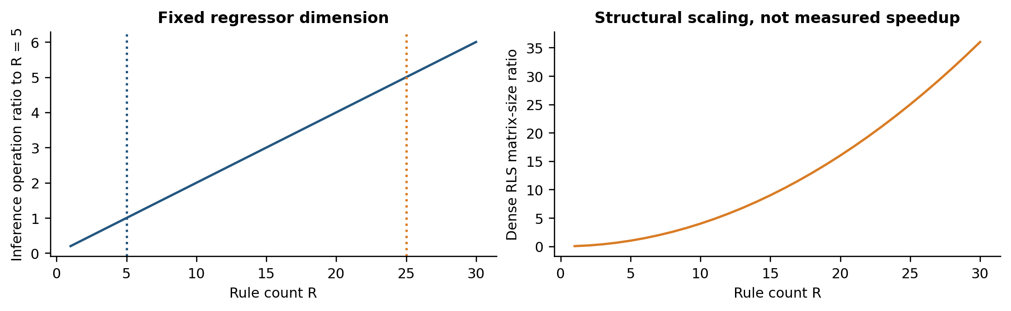
Figure 2. Analytic operation and matrix-size ratios as rule count varies at fixed regressor dimension. The curves show structural scaling; they are not measured speedup or memory benchmarks for ANFIS.
Reducing R from 25 to 5 reduces a fixed-structure inference count by a factor of five. If both models used the same dense RLS formulation and d, the p_{θ}² term would differ by a factor of 25. These are conditional structural ratios. They do not imply that the actual ANFIS implementation is 25 times slower, because ANFIS may use different batch solvers, sparsity, or execution paths. Wall-clock comparisons require the same platform and recorded workload.

6 Experimental results and visual analysis

6.1 Measurement and metric discipline
The recorded study describes MATLAB modeling and a C++ prediction implementation. It reports development across 60 cells, a comparison for cell No. 2, and a field table for cells Nos. 15, 48, and 89. The raw sample series, label counts, split dates, and repeated training runs are not provided in the manuscript-level evidence. The analysis therefore uses these selected aggregate records and does not extrapolate a complete performance distribution for all 60 cells.
Table 3. Metrics that should be distinguished in a reproducible temperature-prediction study.
Metric | Definition | Interpretation
MAE | mean |T − T_hat| | Typical absolute discrepancy in °C
RMSE | sqrt(mean (T − T_hat)²) | Greater weight on large errors
Bias | mean (T_hat − T) | Signed systematic error in °C
Accuracy index | Formula not supplied | Retain separately; cannot interpret as MAE, R² or tolerance coverage
Mean deviation | Signed/absolute convention not supplied | Compare within the same reported column only
Coverage within tolerance | mean 1(|error| ≤ δ) | Requires declared δ, measurement uncertainty, and raw errors

MAE, RMSE, and bias have different meanings. A signed mean error can be close to zero even when positive and negative errors are large. A percentage called “accuracy” is also ambiguous without a formula. In particular, dividing temperature error by an absolute temperature expressed in degrees Celsius produces a unit-origin-dependent percentage: converting Celsius to Kelvin changes the denominator while preserving the physical error. An engineering tolerance coverage, such as the fraction within a prespecified δ °C, has a clearer operational interpretation.
The 99%-level figures are retained as reported indices rather than relabeled as R², percentage within tolerance, or one minus MAPE. The words “mean error” and “mean deviation” are likewise preserved because their signed/absolute conventions are not supplied. No statistical significance or confidence interval is inferred from those aggregates.

6.2 Cell No 2 comparison
Table 4. Reported cell No. 2 comparison and deterministic effect sizes.
Measure | ANFIS | KSI–T–S | Derived change
Mean error (°C) | 2.289 | 0.315 | 86.24% reduction
Rules | 25 | 5 | 80% reduction
Accuracy index (%) | 99.76 | 99.86 | +0.10 percentage points

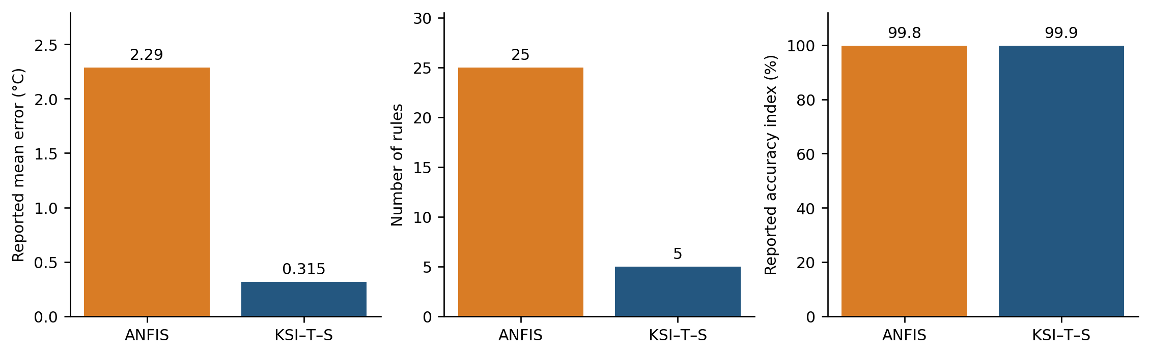
Figure 3. Cell No. 2 reported mean error, rule count, and accuracy index. The separate axes prevent percentages, degrees Celsius, and rule counts from being combined into one arbitrary score.
The reported mean error decreases by 1.974 °C, from 2.289 to 0.315 °C. The relative reduction is 86.24%, and the ratio 2.289/0.315 is approximately 7.27. Thus “two to three times smaller” is not the arithmetic description of this particular pair of values. Rule count decreases by 80%, while the accuracy index increases by 0.10 percentage points. The small percentage-point difference and the large error reduction need not agree numerically because the index formula is unknown.
This is the strongest same-cell comparison in the recorded results, but “same cell” does not itself establish identical train/test intervals or feature availability. The comparison must be accompanied by the exact target checkpoints and pre-update prediction records before it can support a controlled performance claim. Missing traces also prevent inspection of outliers, drift, and the temporal concentration of errors.

6.3 Field results across three selected cells
Table 5. Field values retained from the three-cell comparison. “Earlier predictor” is the historical comparator label; its reproducible implementation and complete patent identifiers are not established by the table.
Cell | Method | Maximum (°C) | Minimum (°C) | Mean (°C) | Accuracy (%)
15 | KSI–T–S | 4.6 | 0.1 | 1.57 | 99.84
15 | Earlier predictor | 4.8 | 1.1 | 2.8 | 88.45
48 | KSI–T–S | 6.2 | 0.8 | 2.94 | 99.71
48 | Earlier predictor | 7.3 | 1.6 | 2.4 | 83.67
89 | KSI–T–S | 11.1 | 0.4 | 6.05 | 99.40
89 | Earlier predictor | 8.6 | 1.9 | 2.6 | 82.56

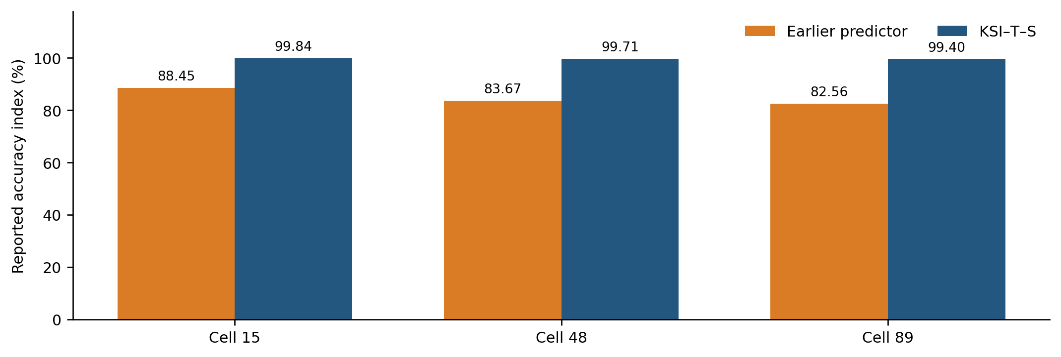
Figure 4. Reported accuracy-index values for the selected field cells. The index remains undefined and should not be interpreted as a standard regression metric.
The increases in reported accuracy index are 11.39, 16.04, and 16.84 percentage points for cells 15, 48, and 89. All proposed values exceed 99% in this selected table. That observation does not establish that every one of the 60 cells achieved the same range, and it does not establish lower absolute error in all three listed cells.
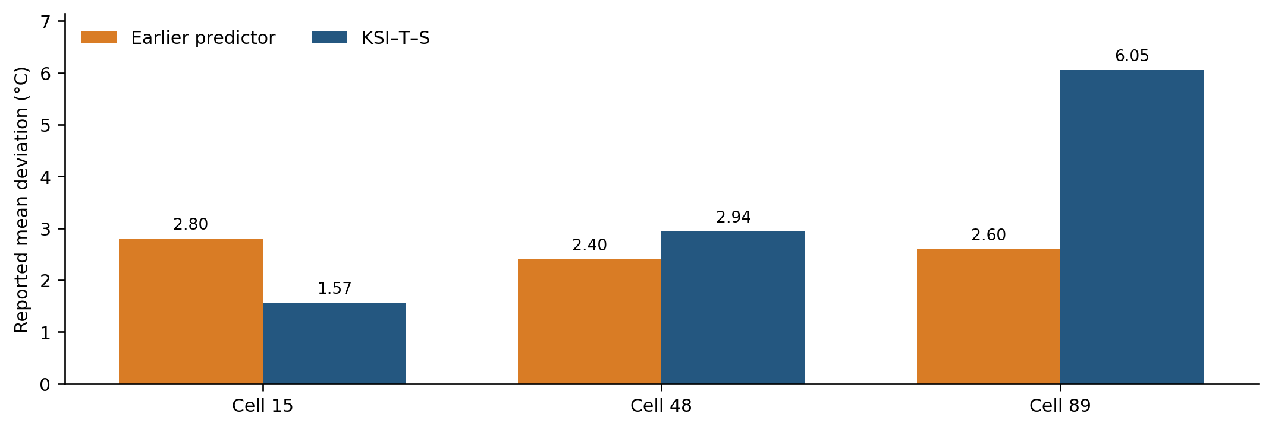
Figure 5. Reported mean deviations by cell. The proposed method is lower only for cell 15 in these rows.
Cell 15’s mean deviation decreases from 2.80 to 1.57 °C, a reduction of 43.93%. Cell 48 increases from 2.40 to 2.94 °C, a deterioration of 22.50%. Cell 89 increases from 2.60 to 6.05 °C, a deterioration of 132.69%. These mixed results are central to the interpretation and should remain visible alongside the favorable cell No. 2 comparison.
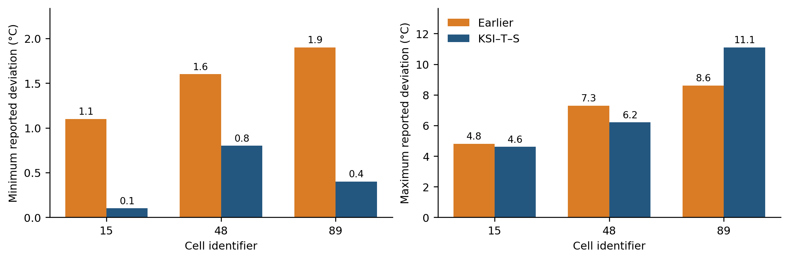
Figure 6. Minimum and maximum reported deviations. These bars are observed summary entries, not uncertainty bounds or error bars around a mean.
Maximum deviation decreases slightly for cell 15 and more clearly for cell 48, but increases from 8.6 to 11.1 °C for cell 89. Minimum deviation decreases in all three cells. A smaller minimum error only indicates that at least one prediction was close; it does not imply a better overall distribution. The cell 89 pattern suggests that the model can be close at some times and substantially less accurate at others, but the cause cannot be diagnosed without its chronological residuals.

6.4 Reconciling the two performance views
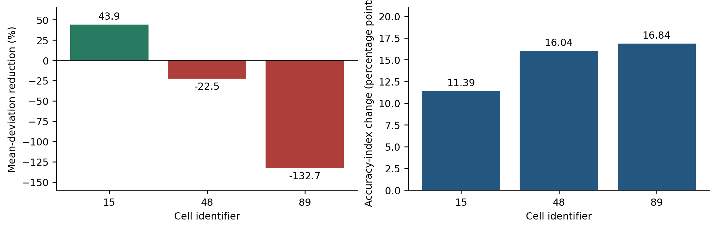
Figure 7. Relative mean-deviation change and absolute accuracy-index change. Negative values in the left panel denote larger mean deviation under KSI–T–S.
A favorable percentage index and an unfavorable error measure can coexist if the index uses a different denominator, tolerance, weighting, or sample population. They can also reflect a reporting error. The available aggregates cannot choose among those explanations. The appropriate next step is to recompute all metrics from the same timestamped prediction–measurement pairs and publish the formulas, units, and sample counts.
Neither the small No. 2 error nor the three-cell accuracy percentages establish superiority over the 2025 LightGBM or 2026 thermal-modeling literature. Those studies use different outputs and datasets. A cross-study bar chart that ranks their numerical Celsius errors would suggest a comparability that the evidence does not support. Table 4 is therefore the quantitative ANFIS comparison, while Section 2 provides the contextual architecture comparison.

6.5 Planned residual and reliability analyses
The most informative additional graphs after the raw records are available are measured-versus-predicted traces at actual thermocouple checkpoints, residuals against time and last-label age, an observed/predicted scatter plot with the identity line, absolute-error empirical distributions, and cell-wise MAE/RMSE intervals. A tolerance-coverage curve can show the fraction of predictions within each engineering error threshold. These figures should be derived from original predictions, not synthesized to match aggregate metrics.
Algorithm 9 Produce a faithful experimental analysis
INPUT issued prediction log; measurement-time labels; quality flags
OUTPUT common-sample metrics and plots with documented denominators
01 Join predictions to measurements using cell ID and measurement time.
02 Retain the prediction issued before the label became available.
03 Apply one prespecified validity mask to every comparator.
04 Compute signed error, absolute error, squared error, and label age.
05 Summarize MAE, RMSE, bias, quantiles, and tolerance coverage by cell.
06 Plot measured checkpoints, residuals, error distributions, and drift.
07 Use time blocks for uncertainty estimation when errors are dependent.
08 Record missing pairs and failure counts alongside every denominator.
09 Publish both macro averages across cells and pooled sample metrics.

Macro-averaging gives each cell equal weight; pooled metrics give greater weight to cells with more observed checkpoints. Both can be useful and neither should be presented without its denominator. Ordinary random folds are generally unsuitable for the deployment question unless their assumptions have been justified [42]. Paired predictive-accuracy tests require origin-aligned losses and a treatment of serial dependence [43].

6.6 Ablation, drift, and uncertainty protocol
The central ablation is the rule-effect operator: complement-of-product, product-of-matches, and product-of-distances must be evaluated with the same rule geometry, consequent dimension, RLS initialization, and label-arrival schedule. Additional factors are rule count, forgetting factor, label delay, missing-label rate, electrical sensor noise, and the inclusion or exclusion of each lagged feature. A blocked rolling-origin design should reserve the final chronological period for testing. When a cell has enough labels, use at least 20 independent origins per condition; otherwise use all available origins and report the reduced precision explicitly.
Table 6. Required online validation matrix for the aluminium-cell soft sensor. The listed levels are factors to predeclare, not unreported results.
Factor | Predeclared levels | Primary evidence | Diagnostic
KSI operator | 1−Πd / Π(1−d) / Πd | MAE, RMSE, bias | Operator and rule weights
Rule count R | 5 / 25 / tuned | Error versus capacity | Latency and memory
Forgetting λ | 1 / candidate grid | Origin-paired loss | Conditioning and update failures
Label delay | 0 / measured delay | Age-stratified error | Stale-label count
Missing labels | 0 / 10% / 20% | Coverage and bias | Denominator and fallback
Electrical noise | 0 / 0.5σ / σ | Residual quantiles | Noise seed and sensor flags
Process drift | Stable / shifted window | Cell-wise error | Regime and parameter version

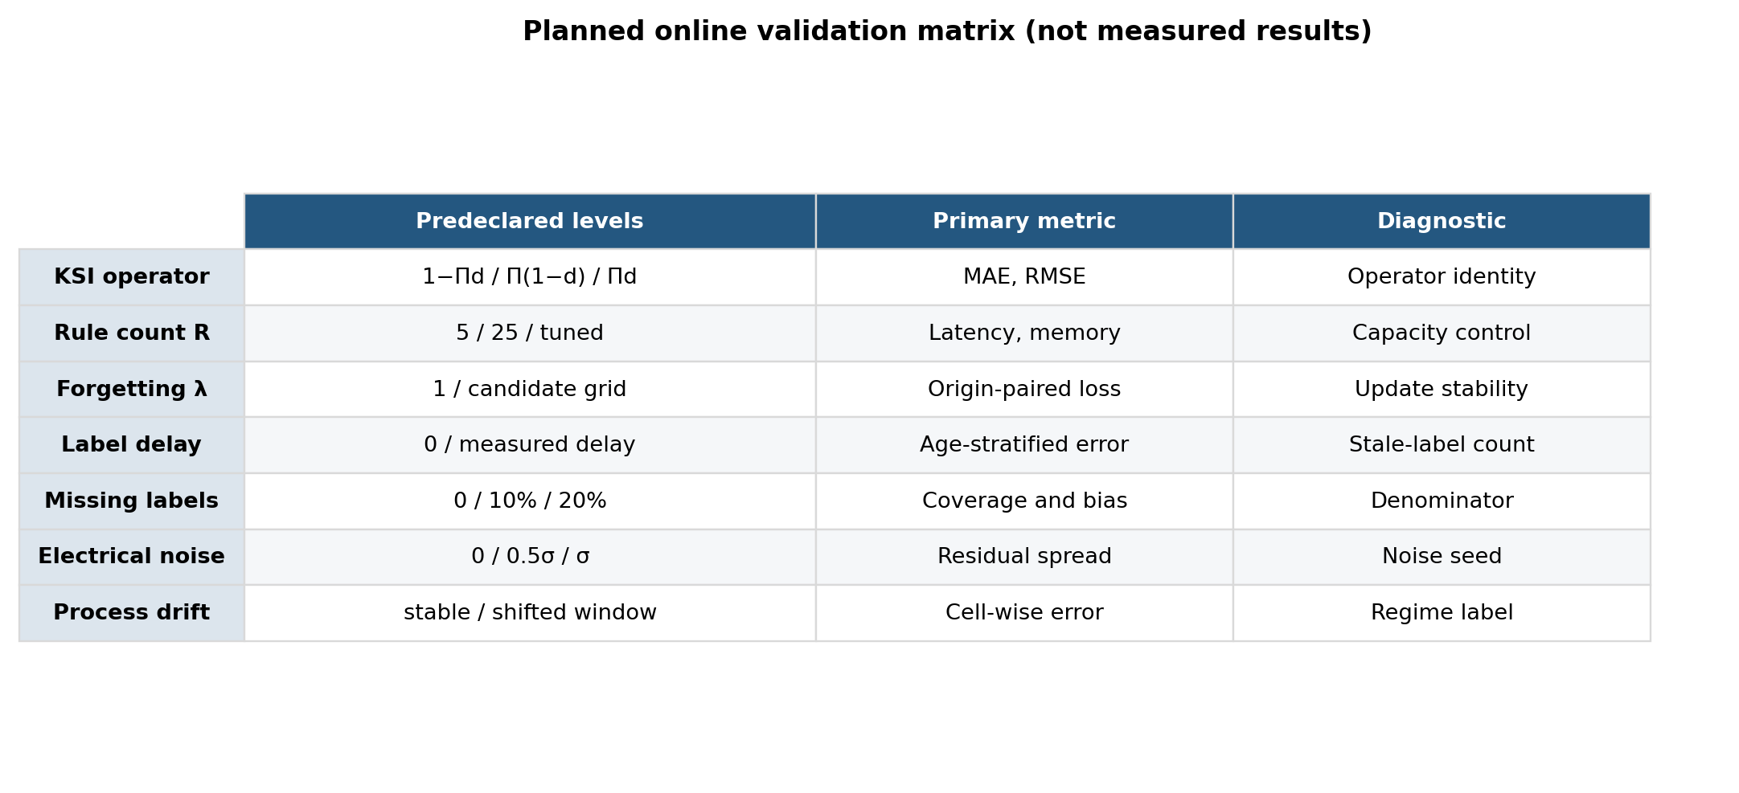
Figure 8. Validation matrix connecting model choices and operating perturbations to the required temperature-prediction evidence. It is a study-design visual, not a measured error surface.
The primary outcomes are MAE, RMSE, signed bias, prespecified tolerance coverage, residual quantiles, label-age-stratified error, fallback frequency, update latency, and memory use. Report cell-level and pooled summaries separately. For comparisons across cells, use a hierarchical or blocked paired analysis; do not treat thousands of electrical samples between sparse labels as independent temperature observations. Confidence intervals should preserve cell and time dependence, for example through cell-level and time-block resampling.
Algorithm 10 Run a leakage-controlled rolling-origin online evaluation
INPUT cell streams; candidate operators; rule counts; forgetting factors; label policy
OUTPUT timestamped predictions, updates, errors, diagnostics, and paired summaries
01 Freeze the chronological split and fit every scaler and rule breakpoint on development data.
02 FOR each cell and each test origin:
03 Form the regressor using only measurements available at that origin.
04 Issue the prediction and store its model version and label age.
05 When a valid temperature label arrives, match it to the stored regressor.
06 Update only according to the declared delay, forgetting, and missing-label policy.
07 Repeat the prediction/update sequence for every candidate operator under the same labels.
08 Log coverage fallbacks, numerical failures, clipping, and update latency.
09 END FOR
10 Compute metrics on identical timestamped pairs and retain failed or missing pairs in denominators.
11 Summarize by cell, time block, label age, and operating regime.
12 Apply paired blocked tests and effect sizes only after checking the number of independent origins.
13 RETURN raw logs, metric definitions, and a reproducibility manifest.

Sensor and numerical uncertainty should be quantified rather than absorbed into the accuracy index. The package should contain thermocouple calibration uncertainty, electrical-channel noise estimates, timestamp jitter, fixed-point or floating-point precision, and the exact treatment of out-of-range inputs. A sensitivity analysis can then distinguish a model failure from a measurement-quality failure. Any prediction clipping must be logged before and after clipping, because clipping can improve a displayed error while hiding an unstable recursive state.

7 Discussion

7.1 What the model contributes
The model offers a small, inspectable rule representation and an inexpensive conditional parameter update. It can issue frequent estimates without pretending that a temperature measurement exists at every electrical sample. Its main operational benefit is the separation of prediction from label-triggered adaptation and the possibility of tracing each output through distances, weights, and local consequents.
The current evidence does not establish that KSI activation is the cause of the cell No. 2 improvement. Fewer rules, different preprocessing, different label handling, and regularization can all affect performance. A same-geometry conventional T–S baseline, a rule-count-matched ANFIS, and fixed versus adaptive variants would isolate these factors. The aggregation ambiguity in Eq. (4) must be resolved before such ablation results can be interpreted.

7.2 Sparse labels and physical limits
High-rate predictions between sparse labels are model estimates. Their apparent smoothness is not evidence of high-frequency accuracy. Validation at three-hour thermocouple checkpoints measures performance at those checkpoints and does not reveal unobserved between-checkpoint extrema. If the intended use is rapid disturbance detection, an additional measurement campaign with suitable temporal resolution is needed.
Voltage/current inputs cannot fully distinguish all thermal states under arbitrary operating changes. Adding feed events, bath composition, tapping, ambient conditions, or measured temperature age may improve identifiability, but changes the feature-burden claim. An honest comparison should quantify the marginal benefit of each additional input against its acquisition cost. A compact model with insufficient information should not be preferred solely for its small rule count.

7.3 Reproducibility requirements
The reproducibility package should provide de-identified chronological data or a documented access route, all cell and sample counts, thermocouple calibration and uncertainty, timestamp conventions, membership breakpoints, lag orders, the exact t-norm/complement formula, RLS initialization and forgetting, coverage fallback, model-update policy, and baseline configurations. It should also identify whether a reported “mean error” is signed, absolute, or otherwise normalized.
The original selected results remain useful for motivating the method, but they do not replace this specification. A simulator can support implementation checks and sensitivity experiments if clearly labeled as simulated; it cannot establish field accuracy. A continuous curve calibrated to a reported mean error likewise does not reconstruct the original measurements.

7.4 Extensions grounded in current research
Interval KSI reasoning and the 2026 distance-based framework suggest possible extensions for uncertain antecedents [17, 18]. Recent thermal surrogates suggest combining compact online correction with physically informed state estimates [4, 5]. Robust losses or outlier-aware updates are another avenue, motivated by the robust ANFIS literature [34]. Each extension changes the model and should be evaluated on the same chronological benchmark rather than assumed to improve it.
Future work should separate three questions: whether the activation operator helps at fixed capacity; whether sparse-label adaptation improves performance under cell drift; and whether the resulting estimates improve an operational decision. Answering the third requires a separate intervention or control study, not only a lower retrospective prediction error.

8 Conclusions
The proposed soft sensor combines moving-distance rule effects, dynamic T–S consequents, and label-triggered RLS for aluminium bath-temperature estimation. The clarified formulation defines the input information set, rule-operator alternatives, parameter dimensions, and delayed-measurement handling. The algorithm descriptions support inspection and replication once the missing configuration details are supplied.
The reported cell No. 2 results show an 86.24% reduction in the stated mean-error measure with five rather than 25 rules. The field table is more mixed: mean deviation improves in one cell and worsens in two, despite increases in a separately reported accuracy index. The figures preserve both findings. A reproducible conclusion about general performance requires defined metrics, exact rule aggregation, original timestamped predictions, and matched-data comparisons across the full set of cells.

References
[1] Kadlec, P., Gabrys, B., and Strandt, S. (2009). Data-driven soft sensors in the process industry. Computers & Chemical Engineering, 33(4), 795–814. https://doi.org/10.1016/j.compchemeng.2008.12.012
[2] Li, X., Lin, J., Liu, C., Liu, A., Shi, Z., Wang, Z., Jiang, S., Wang, G., Liu, F. (2024). Research on aluminum electrolysis from 1970 to 2023: a bibliometric analysis. JOM 76(7), pp. 3265-3274. https://doi.org/10.1007/s11837-024-06596-1
[3] Lin, J., Liu, A., Wang, Z., Shi, Z., Liu, F. (2025). Bath temperature prediction of aluminum reduction cell based on machine learning algorithm. Journal of Sustainable Metallurgy 11, pp. 1419-1430. https://doi.org/10.1007/s40831-025-01027-0
[4] Chen, C., Ran, L., Zeng, Z., Li, J., Cao, X., Wang, Y., Han, B., Zhang, H. (2026). Rapid Prediction of Side Ledge Morphology and Thermal Fields in Aluminum Reduction Cells via CFD-Based Machine Learning. Metals 16(8), 890. https://doi.org/10.3390/met16080890
[5] Novozhilov, I. M., Ilyushina, A. N., Martirosyan, K. V. (2026). Coupled Electro-Thermal Modeling of the Temperature Field in an Aluminum Reduction Cell Using the Finite Difference Method. Processes 14(8), 1284. https://doi.org/10.3390/pr14081284
[6] Betsis, K., Karkalos, N. E., Xenidis, A. (2025). Comparison of machine-learning models in predicting the liquidus temperature of aluminum cryolitic bath. Materials Chemistry and Physics 340, 130865. https://doi.org/10.1016/j.matchemphys.2025.130865
[7] Li, Q., Huang, G., Cui, J., Wang, M., et al. (2025). A temperature field prediction method for aluminum electrolysis cell based on improved CNN-LSTM. 2025 IEEE 14th Data Driven Control and Learning Systems Conference (DDCLS). https://doi.org/10.1109/DDCLS66240.2025.11066020
[8] Zadeh, L. A. (1965). Fuzzy sets. Information and Control, 8(3), 338–353. https://doi.org/10.1016/S0019-9958(65)90241-X
[9] Mamdani, E. H., Assilian, S. (1975). An experiment in linguistic synthesis with a fuzzy logic controller. International Journal of Man-Machine Studies, 7(1), 1–13. https://doi.org/10.1016/S0020-7373(75)80002-2
[10] Takagi, T., Sugeno, M. (1985). Fuzzy identification of systems and its applications to modeling and control. IEEE Transactions on Systems, Man, and Cybernetics, 15(1), 116–132. https://doi.org/10.1109/TSMC.1985.6313399
[11] Sugeno, M., and Kang, G. T. (1988). Structure identification of fuzzy model. Fuzzy Sets and Systems, 28(1), 15–33. https://doi.org/10.1016/0165-0114(88)90113-3
[12] Wang, L.-X., and Mendel, J. M. (1992). Generating fuzzy rules by learning from examples. IEEE Transactions on Systems, Man, and Cybernetics, 22(6), 1414–1427. https://doi.org/10.1109/21.199466
[13] Angelov, P. P., and Filev, D. P. (2004). An approach to online identification of Takagi–Sugeno fuzzy models. IEEE Transactions on Systems, Man, and Cybernetics, Part B, 34(1), 484–498. https://doi.org/10.1109/TSMCB.2003.817053
[14] Kwak, S.-I., Ryu, U.-S., Kim, K.-J. (2019). A fuzzy reasoning method based on compensating operation and its application to fuzzy systems. Iranian Journal of Fuzzy Systems 16(3), pp. 17-34. https://doi.org/10.22111/IJFS.2018.4175
[15] Kwak, S.-I., Kim, U.-H., Kim, K.-J., Son, I.-M. (2020). Fuzzy reasoning method based on distance measure and its reductive property. WSEAS Transactions on Computer Research 8, pp. 73-89. https://doi.org/10.37394/232018.2020.8.10
[16] Kwak, C.-J., Ri, K.-C., Kwak, S.-I., Kim, K.-J., Ryu, U.-S., Kwon, O.-C., Kim, N.-H. (2021). Fuzzy modus ponens and tollens based on moving distance in SISO fuzzy system. Romanian Journal of Information Science and Technology 24(3), pp. 257-283.
[17] Kong, H.-U., Kwak, S.-I., Jang, Y.-J., Hwang, C.-J., Ri, O.-S., Jo, Y.-H., Nam, J.-H., Ryu, U.-S. (2025). New interval fuzzy modeling method based on KSI principle and its application in turf color image evaluation. Journal of Industrial and Management Optimization 21(12), pp. 6713-6735. https://doi.org/10.3934/jimo.2025146
[18] Kwak, S.-I., Jang, Y.-J., Ri, O.-S., Kim, N.-H., Ryu, U.-S., Choe, M.-O., Hwang, C.-J., and Chae, H.-G. (2026). New fuzzy modus ponens and tollens based on least common multiple and its application to fuzzy control. International Journal of Machine Learning and Cybernetics, 17, 431. https://doi.org/10.1007/s13042-026-03162-w
[19] Feced-Mas, V., Mota-Babiloni, A., Navarro-Esbri, J., Udroiu, C.-M. (2026). Novel adaptive neuro-fuzzy inference system (ANFIS) based approach for robust, precise and transparent temperature control in thermal systems guided by explicit design framework. Energy Conversion and Management 366, 121810. https://doi.org/10.1016/j.enconman.2026.121810
[20] Donkor, D. N., Ogudo, K. A., Rameshar, V. (2026). Hybrid Mamdani-ANFIS Data-Driven Control on an Industrial Heating Furnace. Automation 7(3), 84. https://doi.org/10.3390/automation7030084
[21] Zhou, K., Zhang, Z., Liu, J., Hu, Z., Duan, X., Xu, Q. (2019). Anode effect prediction based on a singular value thresholding and extreme gradient boosting approach. Measurement Science and Technology 30(1), pp. 1-11. https://doi.org/10.1088/1361-6501/aaee5e
[22] Lu, H., Hu, X., Cao, B., Chai, W., Yan, F. (2019). Prediction of liquidus temperature for complex electrolyte systems Na3AlF6-AlF3-CaF2-MgF2-Al2O3-KF-LiF based on machine-learning methods. Chemometrics and Intelligent Laboratory Systems, pp. 110-120. https://doi.org/10.1016/j.chemolab.2019.03.015
[23] Cao, B., Cui, J., Li, Q., Wang, M., Li, X., Yan, Q. (2021). Online prediction method of molten aluminium height in electrolytic cell based on extreme learning machine with kernel function. Mathematical Problems in Engineering 2021, 9980194. https://doi.org/10.1155/2021/9980194
[24] Chen, L., Wu, Y., Liu, Y., Liu, T., Sheng, X. (2021). Time-series prediction of iron and silicon content in aluminium electrolysis based on machine learning. IEEE Access 9, pp. 10699-10710. https://doi.org/10.1109/ACCESS.2021.3050548
[25] Lei, Y., Karimi, H. R., Chen, X. (2022). A novel self-supervised deep LSTM network for industrial temperature prediction in aluminum processes application. Neurocomputing 502, pp. 177-185. https://doi.org/10.1016/j.neucom.2022.06.080
[26] Zhu, Y., Xie, S., Xie, Y., and Chen, X. (2023). Temperature prediction of aluminum reduction cell based on integration of dual attention LSTM for non-stationary sub-sequence and ARMA for stationary sub-sequences. Control Engineering Practice, 138, 105567. https://doi.org/10.1016/j.conengprac.2023.105567
[27] Lundby, E. T. B., Robinson, H., Rasheed, A., Halvorsen, I. J., and Gravdahl, J. T. (2023). Sparse neural networks with skip-connections for identification of aluminum electrolysis cell. Proceedings of the IEEE Conference on Decision and Control, 5506–5513. https://doi.org/10.1109/CDC49753.2023.10383251
[28] Breiman, L. (2001). Random forests. Machine Learning, 45, 5–32. https://doi.org/10.1023/A:1010933404324
[29] Friedman, J. H. (2001). Greedy function approximation: A gradient boosting machine. Annals of Statistics, 29(5), 1189–1232. https://doi.org/10.1214/aos/1013203451
[30] Ke, G., Meng, Q., Finley, T., Wang, T., Chen, W., Ma, W., Ye, Q., and Liu, T.-Y. (2017). LightGBM: A highly efficient gradient boosting decision tree. Advances in Neural Information Processing Systems, 30, 3146–3154. https://papers.nips.cc/paper/6907-lightgbm-a-highly-efficient-gradient-boosting-decision-tree
[31] Chen, T., and Guestrin, C. (2016). XGBoost: A scalable tree boosting system. Proceedings of KDD, 785–794. https://doi.org/10.1145/2939672.2939785
[32] Lundberg, S. M., and Lee, S.-I. (2017). A unified approach to interpreting model predictions. Advances in Neural Information Processing Systems, 30, 4765–4774. https://papers.nips.cc/paper/7062-a-unified-approach-to-interpreting-model-predictions
[33] Jang, J.-S. R. (1993). ANFIS: adaptive-network-based fuzzy inference system. IEEE Transactions on Systems, Man, and Cybernetics, 23(3), 665–685. https://doi.org/10.1109/21.256541
[34] Nik-Khorasani, A., Sadoghi-Yazdi, H., Mehrizi, A. (2024). Robust hybrid learning approach for adaptive neuro-fuzzy inference systems. Fuzzy Sets and Systems 481, 108890. https://doi.org/10.1016/j.fss.2024.108890
[35] Gama, J., Žliobaitė, I., Bifet, A., Pechenizkiy, M., and Bouchachia, A. (2014). A survey on concept drift adaptation. ACM Computing Surveys, 46(4), 44. https://doi.org/10.1145/2523813
[36] Hewamalage, H., Ackermann, K., and Bergmeir, C. (2023). Forecast evaluation for data scientists: Common pitfalls and best practices. Data Mining and Knowledge Discovery, 37, 788–832. https://doi.org/10.1007/s10618-022-00894-5
[37] Tashman, L. J. (2000). Out-of-sample tests of forecasting accuracy: An analysis and review. International Journal of Forecasting, 16(4), 437–450. https://doi.org/10.1016/S0169-2070(00)00065-0
[38] Ljung, L. (1999). System Identification: Theory for the User. 2nd ed. Prentice Hall.
[39] Goel, A., Bruce, A. L., and Bernstein, D. S. (2020). Recursive least squares with variable-direction forgetting: Compensating for the loss of persistency. IEEE Control Systems Magazine, 40(4), 80–102. https://doi.org/10.1109/MCS.2020.2990516
[40] Tanaka, K., and Sugeno, M. (1992). Stability analysis and design of fuzzy control systems. Fuzzy Sets and Systems, 45(2), 135–156. https://doi.org/10.1016/0165-0114(92)90113-I
[41] Tanaka, K., and Wang, H. O. (2001). Fuzzy Control Systems Design and Analysis: A Linear Matrix Inequality Approach. Wiley. https://doi.org/10.1002/0471224596
[42] Bergmeir, C., Hyndman, R. J., and Koo, B. (2018). A note on the validity of cross-validation for evaluating autoregressive time series prediction. Computational Statistics & Data Analysis, 120, 70–83. https://doi.org/10.1016/j.csda.2017.11.003
[43] Diebold, F. X., and Mariano, R. S. (1995). Comparing predictive accuracy. Journal of Business & Economic Statistics, 13(3), 253–263. https://doi.org/10.1080/07350015.1995.10524599

